Building Permit Information

City of Arco
All building specifications are in accordance with the 2009 IRC. A building permit must be obtained from the Building Department at 302 W Grand, Arco, Idaho Investigation Fees are charged where work is started before obtaining a building permit.
Information needed with your application: (PLEASE FILL IN ALL INFORMATION)
- 2 copies of your submittal documents are required as per section 106. One will be submitted with your application to the building department. The other must be available at the job site at all times.
- Plans must include a plot plan showing the location of the proposed building on the site.
- A copy of a valid sewer permit
- The appropriate fee according to the City of Arco Fee schedule
- Any other item that the building department deems appropriate
- All submittals require an estimated cost of construction, bid construction cost and final amended as built construction cost.
- Energy compliance Certificate, using 2015 IECC Residential Check Software. Software may be obtained by downloading from www.energycodes.gov.
When you submit your application make sure that you have the correct property description. That your lot size is appropriate for the zone that you are building in and whether you are in a flood zone.
Upon approval pour permit will be issued in 3 to 4 business daps.
If any ofthese items are incorrect, it could delay your application!
Inspection Record Card
An inspection record card is assigned to the permit holder when the permit is issued. This card must be posted in a conspicuous place on the premises and in such a position as to allow the building inspector conveniently to make the required entry thereon regarding inspection of the work. The permit holder must maintain this card in such a position, until after the work is completed and a final inspection has been made.
Inspections All specifications are in accordance with the 2012 IRC. It is the responsibilitp ofthe permit holder or his agent to notilp the building inspector 48 hours in advance of anv inspections required. (All inspections will be done after 5:00pm)
The permit holder or his agent must notify the building department when work is ready for inspection. In addition to special inspections which may be necessary, the following inspections are required:
l . FOOTING INSPECTIONS; Trenches are excavated to the proper depth and rebar is in place in the footings and dowels are set.
- FOUNDATION; Forms are in place, rebar in position, both horizontal and vertical, any block outs in place. Cold joints must be doweled.
- FRAMING INSPECTION; To be made after the roof, all framing, fire blocking and bracing are in place and all pipes, chimneys and vents are complete and rough electrical, plumbing and heating wires and pipes and ducts are approved.
- ENERGY INSPECTION; Must meet energy code as stated in the 2015 IECC, International Energy Conservation Code.
- SHEETROCK; After sheetrock is installed, BEFORE taping.
- FINAL INSPECTION; To be made after finish grade and building is completed and ready for occupancy. There will be no occupancy until the City of Arco Inspector makes the final inspection. Other inspections and a survey of the lot may also be required by the public building official to verify compliance of the structure with approved plans and zoning ordinances.

Certificate of Occupancy
The code requires that a certificate of occupancy be posted in a conspicuous location in the building when needed in commercial applications. This posting makes it possible for personnel of the building department as well as other agencies to determine whether or not the building is being used in compliance with the code.
If you have questions or need to reschedule an inspection: Call 208-317-7065,
For inspections, call 48 hours in advance Building Inspector; Craig Wornek
City of Arco Residential Building Permit Application
Contractor
AddressPhone #
Owner
Address Phone #

Legal Description:
Platted SubdivisionBlockLot
Section Township Range Tax Parcel
Single FamilyMulti-Family Addition Garage Other
Square Footage's: Bsmt.Main
Second GarageOther
Number of Bedrooms:
Type of Heat: Nat. Gas Oil Propane Elec.
Contractor Number
Sewer Permit#
Construction Cost
Sub Contractors & Numbers

List Of Requirements For Submitting Plans To Obtain A Building Permit On Single And Multiple
Family Dwelling Units, Additions and Detached Garages and any other Structures
- A plot plan must accompany all plans indicating all property lines, set backs, easements, legal description,
North designation, name of owner, shows all structures and dimension.
- Footing or Basement plans consisting of:
  - Fully dimensioned plan.
  - Footing showing dimensions and locations, and steel requirements.
  - Exterior walls showing location and size of all door and window openings, with window well depth.
  - Interior walls showing location of all bearing walls, beams, beam sizes, and width of any openings, doors, etc.
  - Room designation, bedrooms, bath, etc.; and if basement is finished.
- Main and Second floor plans consisting of:
  - Fully dimensioned plan.
  - Exterior walls showing location and size of all window and door openings.
  - Interior walls showing location of bearing wall, beam sizes, and width of any openings, door, etc.
  - Room designations, kitchen, bedroom (s), bath (s), living room, etc..
- Roof Trusses by approved manufacturer and full layout detail supplied ( No Homemade allowed).
- a. All four elevations, front, rear, and sides, showing orientation, N. S. E. W.
b. Extent of foundation walls and footings, including retaining walls.
- Building cross section (s) consisting of:
  - Footing to roof, showing roofing material, (Note: all cedar shingles and shakes must be number 1), all vertical.
dimensions, finished floor, to ceiling, footing depth, insulation R-value of exterior walls, types of wall covering, drywall, brick, stucco, siding, etc..
  - Stair sections, including railing height, riser height, tread width, headroom height, any railing (s),
- Complete door and window schedules, make, type, size distance from floor, U-value, any special glazing (i.e.
tempered).
- Driveway and drainage swale design, and storm drainage runoff design, if required.
- Layout of heating supply and return ductwork, sizing and location, including combustion air and exhaust air.
- Return this sheet completed along with all other required documents.
Received By: Date:

Reviewed By:
Building Inspector Date:

City Maintenance

Date:

P & Z Official

Date:

Valuation Worksheet
No Building Permit is required (but electrical and plumbing permits may be) for:
- Re-roofing
- Storage sheds less than 200 sq.ft.
3, Signs (as permitted by ordinance)
- Single purpose (commodity storage) agricultural buildings
- As determined by the building official
- As determined by the Arco City Council

EXCEPTIONS
- Fence Permit Fee (Fences over 6ft.) $7
- Portable Sign $12
VALUATION
Valuation used to determine the Building Permit fee shall be based on the contractors certified price for construction, or as follows:
Residential
Living Space= | $50.00 sq.ft. (wood) $56.00 sq. ft (masonry)
Garage | $18.00 sq. ft (wood) $21.00 sq. ft (masonry)
Unfinished Space= | $11.00 sq. ft. (basements, etc.)
Open Carport | $12.50 sq. ft
Air Conditioning= | Add $2.50 sq. ft
Fireplace— | Add $1500.OO
Living space x $50.00(wood) $56.00(masonry) Garage space x $18.00(wood) $21.00(masonry)
Unfinished SpaceX $11.00+
Air Conditioning add $2.50 per sq. ft. Fireplace add $1 ,500.OO

Total Valuation
Basic Fee

Basic Fee x $amount x additional $1,000.
Other Inspection Fees=
Exceptions=
Plan Check Fee for Commercial Only—

TOTAL FEE =
 | OTHER INSPECTIONS AND FEES
1. | Inspections outside of normal business hours (All inspections will be done after 5:00pm)
2. | Re-inspection fees assessed under provisions of Section 108 | $47
3. | Inspections for which no fee is specifically indicated
 | (minimum charge one-half hour | $47 hr.
4. | Additional plan review required by changes, additions,
 | or revisions to approved plans (minimum charge one-half hour) | $47 hr.
5. | Plan check fee in amount of 65% of Building Fee Will be charged for commercial projects

Contacts
Building Inspector:  Craig Wornek  Phone: 208-317-7065  48 hour notice required  Notes: | Contacted []
City Maintenance  Tony Chisum  Phone: 208-527-8294 (city office) Approaches  Notes: | Contacted[]
Electrical Inspector:  Rick Doyle  Phone208-251-3546  Inspection Request 800-839-9239  Notes: | Contacted[]
Plumbing Inspector:  Mike Carter  Phone: 208-546-1653 Notes:  HVAC Inspector:  Mike Carter  Phone: 208-546-1653  Notes: | Contacted[]
Health Department Contact Brigetta  412 W. Pacific, Blackfoot, Id 83221  Phone: 208-785-2160  Notes: | Contacted[]
County Building Department
Lucy Lutschg
Memorial Annex
PO Box 413, Arco, Idaho 83213
Phone: 208-527-4516
For All State Inspection Requests: 1-800-839-9239

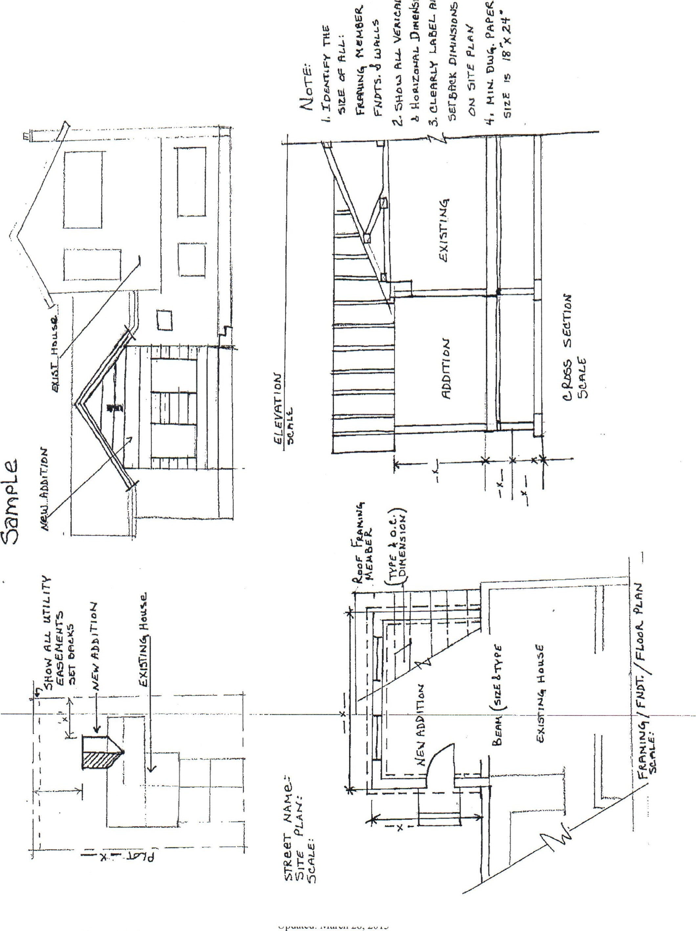

FILL-IN-THE-BLANK WALL SECTION DETAIL AND RETURN
ROOF SNOW LOAD 35 PSF

Pre enginccrcd Trusses by Roofing Type:
Sheathing Size:
Exterior Siding
Sub Sheatin
Wall Stud o/c
Ground to Wood 6" minimum 2% Ground Slope From
Dwelling
Min.
30" frost Depth
Damp Proofing Required Below grade.
x Footing
On undisturbed soil
1
Top Plates
Header Typical
Wall Bracing in accordance with IRC

& IBC 2009
Window Mfg
Style | U-Value  Gyßsum Board
R Value | Wall Insulation
Floor Sheating
Redwood or Treated Sill Plates Required when in contact with
@L.Concrete
1/2" x 10' Anchor Bolts @ 6' o/c Max. 12" Inax. from end of2x
" Thick Concrete Wall
¹/2' f/ 4 Rebar@ 24" o/c Horiz &
Velt. miff.-
R Value Wall Insulation
Min. Elect. R-19 all other R-l I
4" concrete floor
x 12 Pitch
Attic Ventilations: Type & how much
R-Value Ceiling
Insulation
Interior Walls
Cross Bridging as
Required by Code
Floor Joist type & size
Bearing Walls
Crawl space Ventilation:
Type & how much
Insulation in Bsmt to be covered w/gypsum bd. Or flame ret. Vis.
All rebar to be tied in place
Ftgs. Included
4' of Washed gravel
Reqllired under BSIüt.
Floor on Elect. I-leated Homes.

(2) 1.2 — 4 Rebar continious

PLOT PLAN
Setback Aren: Means the space on a lot required to be left open and unoccupied by ceilings or structures, either by the front, side or rear yard requirement, or be delineation on a recorded subdivision map. In Agricultural Areas-and-Transitional Ag Zones:
front yard-no building or structure shall be erected nearer than fifty (50) feet from the properly line adjacent to the street.
Side yard: No building shall be erected closer than twenty (20) feet to any side property line, except corner lots shall maintain a thirty (30) foot side yard adjacent to the street which intersects the street upon which the building fronts.
Rear yard: There shall be a rear yard having a depth of not less than twenty-five Feet.
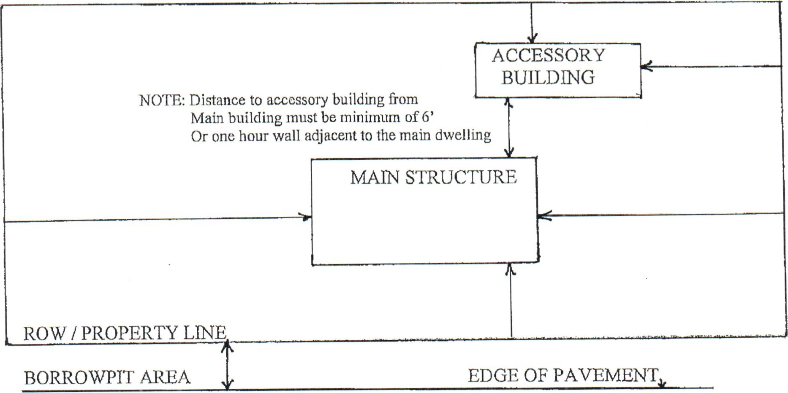
CENTER LINE OF ROAD
UNDER FLOOR CLEARANCE
Floor |  |  |  | Joist
 | 18" min. |  |  | 6-mit black visqueen vapor barrier ground cove
 |  | 12" min.

